Consider the following example:

<https://www.postgresqltutorial.com/postgresql-tutorial/postgresql-recursive-query/>

Here is an illustration of what they are representing:

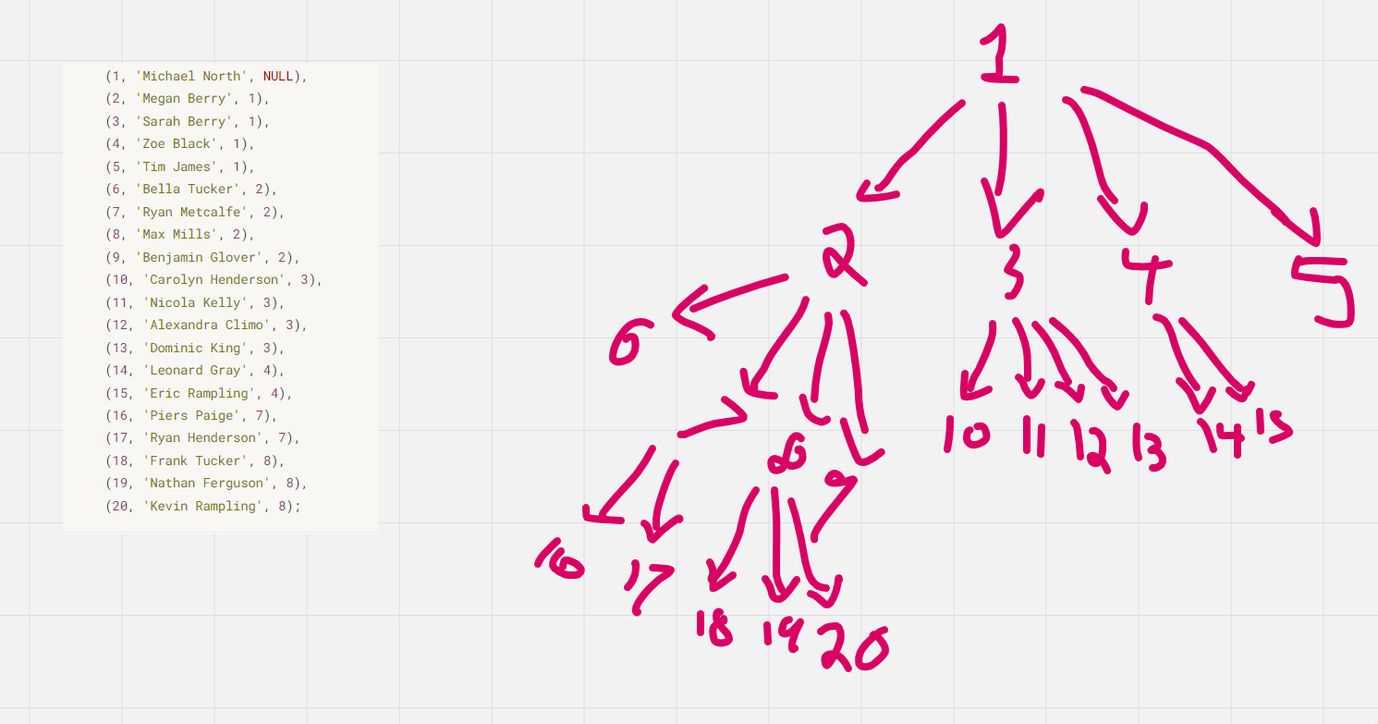

Aside from the recursion seen on that page. Here is another way to try and get a result set based on chain of command:

with ranks as

(SELECT e1.employee_id as rank_1, e2.employee_id as rank_2, e3.employee_id as rank_3, e4.employee_id as rank_4 FROM employees e1

JOIN employees e2 ON e2.manager_id = e1.employee_id

FULL JOIN employees e3 ON e3.manager_id = e2.employee_id

FULL JOIN employees e4 ON e4.manager_id = e3.employee_id

WHERE e1.employee_id = 2 )

SELECT*FROM employees

WHERE (employee_id IN (SELECT rank_1 FROM ranks))

OR (employee_id IN (SELECT rank_2 FROM ranks))

OR (employee_id IN (SELECT rank_3 FROM ranks))